**Sec. 230.065. - General guidelines for historic contributing resources.**

(a) Except as otherwise provided in this chapter, the property shall be used for its historic purpose, or for a similar purpose that will not alter street access, landscape design, entrance(s), height, footprint, fenestration, or massing.

**Response: Property is used as a theater/performing arts center. This is a continuation of the historic purpose of the resource.**

(b) Historic materials, finishes, and distinctive features shall, when possible, be preserved and repaired according to historic preservation methods.

**Response:**

**Roof ornamentation: The most recent rooftop ornamentation was made of wood and likely installed in 2002. Photos suggest that this was the third iteration of these distinctive, architectural pieces. After 20 years, the most recent pieces began rotting and pieces fell to the sidewalk requiring removal for safety. The new three-dimensional sections will be constructed of aluminum to ensure a much longer life and public safety in the Oregon rain . They have been designed to closely resemble the ones that fell, which were designed after the original terracotta rooftop pieces. To use terracotta today would be cost prohibitive, probably in the $200,000 range for fabrication vs. $21,150 in aluminum.**

**Elsinore blade sign:** **The proposed sign is a reconstruction of a missing distinctive feature, so no historic materials are being significantly affected. The blade sign, although very similar to the original, has been designed to be 23 feet tall, shorter than original. The original height rose further than the top of the roof. The shorter size was determined by the designer to lessen the weight of the sign for structural purposes.**

**Marquee:** **The work to the marquee will remove existing non-historic under-canopy lighting replace with more historically accurate lighting. This will restore the visual appearance closer to historic character.**

**Entry/Ticket area: The deteriorated flooring tile installed in a previous renovation will be replaced with tile of matching size and color, and door hardware will be replaced with a more accurate replica. This will not impact historic materials.**

**Overall: The proposed work involves a lot of lighting, but that is consistent with the historic character of this building type. This is an image of the theater at night from the 1930s, and the proposed blade sign and marquee displays, although brighter than currently, will not be as bright overall as the historic appearance of the theater.** 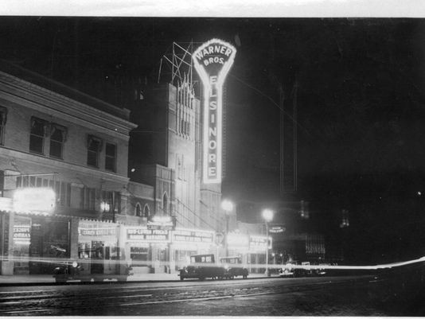

(c) Distinctive stylistic features or examples of skilled craftsmanship significance shall be treated with sensitivity.

**Response: The proposed project is not impacting historic materials, but replacing missing ones, or deteriorated previous replacements with more accurate ones. The treatments proposed retain the features necessary to convey the distinctive theme of the theater, as well as the elements that identify it as a historic theater. The addition of the blade sign will return a historic feature integral to theatres that was previously removed.**

(d) Historic or original features shall be restored or reconstructed only when supported by physical or photographic evidence.

**Response: This project does include restoration or reconstruction of features, including the vertical blade sign, the rooftop crown ornamentation, the under-marquee light fixtures, and wall tile. Photographic evidence is included for these items as follows:**

* **Vertical blade sign (excluding Fanchon and Marco letters – a touring vaudeville act in the late 1920’s)**
* **Rooftop crown ornamentation**
* **School house lights under the marquee**
* **Individual aluminum shades for marquee lightbulbs**
* **Tile on exterior walls**

(e) Changes that have taken place to a historic resource over the course of time are evidence of the history and development of a historic resource and its environment, and should be recognized and respected. These changes may have acquired historic significance in their own right, and this significance should be recognized and respected.

**Response:**

**The blade sign, although not in existence when the theater opened in May of 1926, was added shortly after, in 1928 (per written recollection), within the period of significance for the theater and the district.**

(f) Additions and alterations to a historic resource shall be designed and constructed to minimize changes to the historic resource.

**Response:**

**The blade sign, although very similar to the original, has been designed to be 23 feet tall, shorter than original. The original height rose further than the top of the roof. The shorter size was determined by the designer to lessen the weight of the sign for structural purposes.**

(g) Additions and alterations shall be constructed with the least possible loss of historic materials and so that significant features are not obscured, damaged, or destroyed.

**Response:**

**Significant features will not be damaged or destroyed. The blade sign was a historic feature, so the new installation will use historic attachment points. The current deteriorated rooftop ornamentation is a non-historic replica, so the new replacement will not remove historic material. The entrance tile was similarly installed as a replacement, so no historic tile is being replaced, but the historic size and color of the historic tile is being retained.**

(h) Structural deficiencies in a historic resource shall be corrected without visually changing the composition, design, texture or other visual qualities.

**Response:**

**No structural deficiencies are presently known.**

(i) Excavation or re-grading shall not be allowed adjacent to or within the site of a historic resource which could cause the foundation to settle, shift, or fail, or have a similar effect on adjacent historic resources.

**Response:**

**No regrading or excavation will be occurring.**