***Tree Variance***

**Proposal:**

The subject property is about 52.80 acres in size and zoned RA (Residential Single Agriculture). The applicant is proposing to divide the subject property into 214 single family residential lots (within 11 Phases/Sections).

There are ten (10) Oregon White Oaks 24” in diameter or greater located throughout the site. The applicant is removing six (7) of these significant trees.

Lot 3-Oak 32” Remove

A Avenue-Oak 28” Remove

A Avenue-Oak 24” Remove

A Avenue-Oak 60” Remove

Lot 68-Oak 30” Remove

J Avenue-Oak 24” Remove

Lot 74-Oak 40” Preserve

Lot 168-Oak 48” Preserve

Reed Road-Oak 32” Remove

Reed Road-Oak 24” Preserve

***Criteria***

**Tree Variance 808.045(d)(1):**

1) Hardship-

(A) The site being developed is 52.80 acres in size and zoned RA. All Oregon White Oaks designated for removal are within the right-of-way, the building envelops or within an area close to the building envelope, which have the potential of being damaged during grading and construction. The site has been designed to accommodate a safe and efficient circulation system, adequate parking, and meet the standards all while taking into consideration topography, stormwater detention, and street connections.

Due to the topography and required street connections on the site, these areas where the trees are located couldn’t not be avoided and therefore, created a hardship by impacting how the site could be laid out. We have made significant efforts to retain the required 25% of trees on the site, but the removal of these significant trees cannot be avoided. Therefore, the trees proposed for removal are located within the proposed accessways and the proposed building envelopes.

The 32” Oregon White Oak designated for removal is located in very close to street improvements required by PWDS and specifically within the area where a sidewalk is required. In order to preserve that tree, the required street improvements would need to be significantly reduced. The required improvement is to construct a local street. A reduction to the improvement wouldn’t be practical.



The 24”, 28”, and 60” Oregon White Oak designated for removal are located with A Avenue. A Avenue is necessary in order to provide street connections and circulations throughout the subdivision. The intersection of A Avenue and Strong road is dictated by site distance constraints of Strong Road as well as topographic constraints of the site.



The 30” Oregon White Oaks designated for removal are located within Lot 67. This tree is located in the potential building area and will be affected by the construction of a driveway, sidewalk and installation of public utilities. This tree must be removed to accommodate a driveway, sidewalk and installation of public utilities.



The 24” Oregon White Oak designated for removal is located within J Avenue. Avenue is necessary in order to provide street connections and circulations throughout the subdivision.



The 40” Oregon White Oak designated for preservation is located on Lot 73. All preservation measures will be taken to ensure protection of this tree during grading and construction of the site.



The 48” Oregon White Oak designated for preservation is located on Lot 168. This tree is located within an area of this lot that allows the project developer to create a wider lot than the rest in order to preserve this tree. All preservation measures will be taken to ensure protection of this tree during grading and construction of the site.

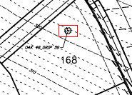

The 32” Oregon White Oak designated for removal is located very close to street improvements required by PWDS and specifically within the area where a sidewalk is required. In order to preserve that tree, the required street improvements would need to be significantly reduced. The required improvement is to construct a minor arterial. A reduction to the improvement wouldn’t be practical.

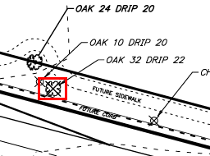

The 24” Oregon White Oak designated for preservation is located along the Reed Road frontage. This tree is located far enough away from the proposed street improvements, that we propose meandering the sidewalk around the tree in order to preserve this tree. All preservation measures will be taken to ensure protection of this tree during grading and construction of the site. This tree will be within the right of way dedicated and will therefore become a Tree within City Owned property and under the jurisdiction of chapter 86 at that time. As such, we will likely need a permit to construct improvements with the critical tree zone.

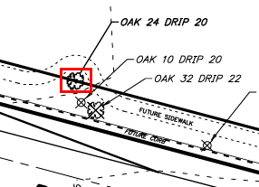

(B) The proposed variance is the minimum necessary to allow the lawful development of the site. There are 10 significant trees (Oregon White Oaks) located throughout the subject property. The applicant is requesting to remove 7 of those significant trees in order to develop the site.